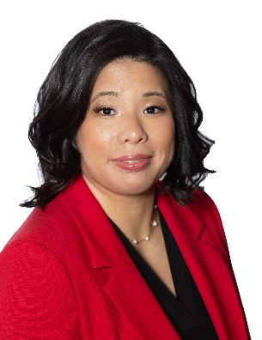
Attorney, O’Neil Wysocki, P.C. Sandy@OWLawyers.com Tel : (972) 852-8000
Sandy M. Liu
Family law, according to attorney Sandy Liu, touches on what people value the most, beyond money and possession – their family. Giving a client hope during the initial conference and seeing them through to resolution makes practicing family law meaningful to her.
Ms. Liu graduated from the University of Texas at Dallas with a Bachelor of Science degree in Molecular Cell Biology, but science was not her life’s calling. Instead, she enrolled in St. Mary’s University School of Law, where she served as a Staff Writer on the school’s law review, was recognized for academic achievement by listing on the Dean’s List and won the Ladas Memorial Award for Writing Excellence. During law school, she clerked for the Fifth District Court of Appeals in Dallas.
A published author, Ms. Liu has 16 years of extensive trial experience in family law litigation, particularly in the areas of child support litigation and family immigration issues. Born in Taiwan, Ms. Liu has a unique perspective due to her immigrant background and her previous experiences as an Assistant Attorney General for the State of Texas and as a managing attorney for a non-profit organization helping victims of family violence and human trafficking.
A native speaker of Mandarin Chinese with proficiency in Cantonese and French, Ms. Liu is married and has two children, one dog, one cat, and two pet lizards.

Bar Admissions
- State Bar of Texas, 2003

Education
- St. Mary’s University School of Law, Doctor of Jurisprudence (J.D.), May 2003
- Staff Writer, St. Mary’s Law Journal
- Dean’s List
- 2002 Ladas Memorial Award for Writing Excellence
- University of Texas at Dallas, Bachelor of Science, Molecular Cell Biology, 2000

Presentations & Publications
- Postpartum Psychosis: A Legitimate Defense for Negating Criminal Responsibility? 4 Scholar 339
- After WTO Accession: China’s Dilemma with the Trafficking of Fakes, 93 Trademark Rep. 1153
- Post-Judgment Motions, Texas Assistant Attorney General Conference 2017

Memberships
- State Bar of Texas
- Family Law Section, State Bar of Texas
- Asian Pacific Interest Section, State Bar of Texas
- College of the State Bar of Texas
- Dallas Bar Association
- Family Law Section, Dallas Bar Association
- Dallas Asian American Bar Association, Dallas Bar Association
- Dallas Women Lawyers Association, Dallas Bar Association
- American Immigration Lawyers Association
- Collin County Women Lawyers Association

Community Service
- Rotary Club of Allen
- Leadership Program – Allen/Fairview Chamber of Commerce
- Art & Music Guild of McKinney

